Задание на 30.03.2020
Тема занятия: Окружающий мир. Активизация в речи ранее изученной лексики. 1. Для повторения изученных слов пройдите по ссылке: https://resh.edu.ru/subject/lesson/655/ Раздел: Лексика. 2. Прочитайте следующий текст и выполните упражнения к нему:

The Brown Bear.

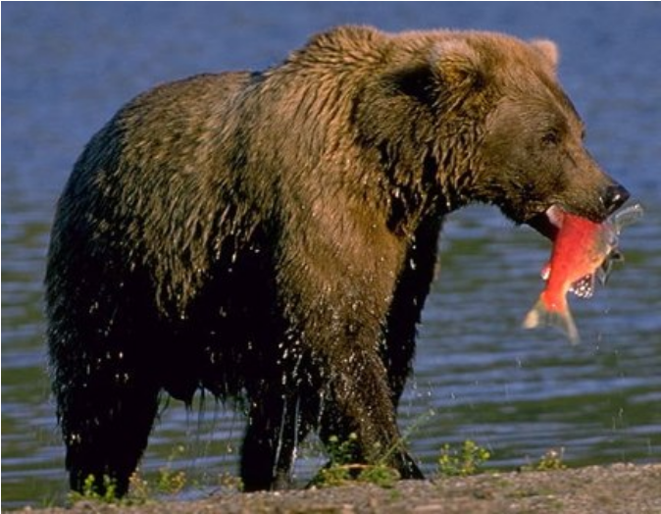
The brown bear is a large animal. Its coat is thick. It has a short neck, its head is big, and its tail is very short.The brown bear lives in the forest. It likes to make its home in a hollow tree. It eats fruit and berries which it finds in the forest. The brown bear also likes honey, and it gets it in the hives of the wild bees. The wild bees make their hives in the trees, and the brown bear find them by the smell of the honey. When it finds a hive, it climbs the tree, and for hours and hours it gnaws the bark. It makes a hole in the tree, pushes its paw through it and gets the honey.During the winter months the brown bear sleeps. It lies in a den where it makes a bed of leaves for itself. The snow comes and covers its den. It closes its eyes and sleeps there al winter.When spring comes, the brown bear wakes up and begins to walk about the forest.
brown bear - бурый медведь coat - мех, шерсть thick - густой hollow tree - дуплистое дерево hive – улей smell – запах for hours and hours – часами to gnaw – грызть bark – кора hole - дыра, отверстие to push through – просовывать paw – лапа den – берлога to walk about - бродить по
Answer the questions:

1. Where does the brown bear live?
2. Where does it like to make its home?
3. What food does it like to eat?
4. Where does it find honey?
5. What helps it to find the hives?
6. How does it get the honey?
7. What does the brown bear do in winter?
8. When does it wake up again?
3. Прочитайте рассказ и придумайте название:
One day a boy finds a brown bear-cub in the forest. He is very little and looks like a puppy. The boy carries him home. Soon the bear-cub becomes as tame as a dog. Every day the boy goes to school. The bear-cub goes with him and waits for the boy in the field. At first the other boys are afraid of the bear-cub, but soon they become great friends. Many of them bring baskets of food to school, and they give the bear-cub some bread and butter. The bear-cub lives with the boy for a long time. But one day he goes to the forest and does not come back. Everybody is very sorry for the bear-cub… Many years pass. New schoolboys come to the old school. One very cold winter day the door opens, and a large brown bear walks into the classroom. Oh, how frightened the boys are! Some run to the door, others jump out of the window. But the bear does not touch the pupils. He walks up to the fire and warms himself. He feels quite at home. He is very glad to get into such a warm room. He sits by the fire, and then walks up to the table where the boys’ baskets for food lie and eats some bread. Then the bear walks out of the house. Some young men in the village come with their guns to kill the bear. They soon find him but do not kill him. They saw some marks on his skin that this bear is the old friend of their schooldays. They let him go back into the forest.
Words and phrases:
cub - детёныш дикого животного to carry – нести as tame as - такой же ручной, как to wait – ждать at first – сперва to be afraid of – бояться to pass – проходить frightened – испуганный to touch – трогать to warm – греться quite - вполне, совсем to get into - попасть в mark – отметина
3. Сделайте проектную работу на тему: «Животные на грани исчезновения»
Ответы присылайте на электронную почту: ya.zulfya2013@yandex.ru

